PRACTICAL-5

**Aim:** Calculate cost estimation for your SGP project using LOC, Function Point and COCOMO.

**Software Required:** System Star Tool

**Knowledge Required:** Basics of Software Engineering

# Reports:

# 

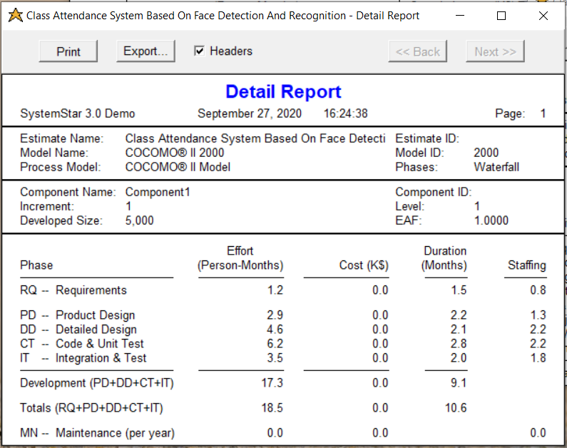

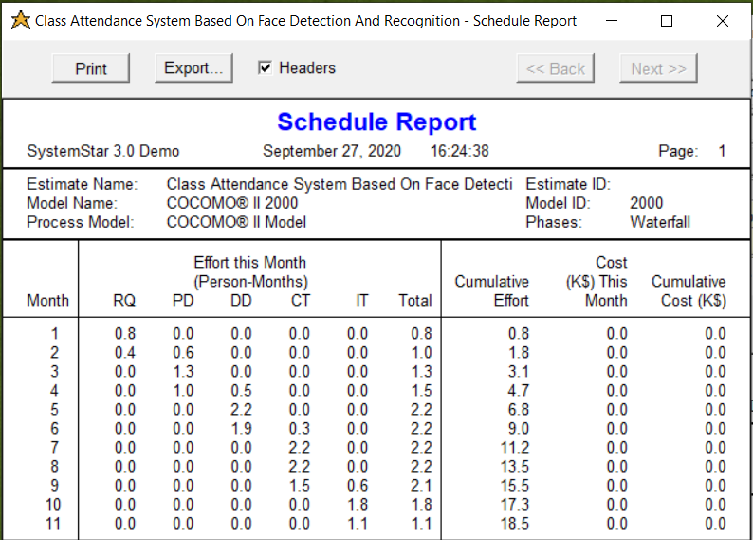

**Conclusion:**

In this practical, I have learned about LOC, COCOMO Model and using System Star tool generated the reports for our ecommerce web application project.